
Dhaka International University
Lab Report details:
Lab Report Topic : Java Method Overloading Exploited & Understanding Variable-Length Argument Lists in Java
Lab Report No : 07
Course Title : Object-Oriented Programming Languages
Course Code : 0613-202

Submitted By: | Submitted To:
S M Nabil Ausaf  Roll: 01  Reg No: CS-D-91-23-124492 | Prof. Md. Abdul Based

Date of Submission: ‎13-‎Oct-‎24

Code 1: Java Method Overloading Exploited (Data Type)
Objective
The objective of this lab is to understand the concept and implementation of method overloading in Java through the use of a custom class called BDataType. We are going to create a class that will contain methods with identical names but with different types of parameters. Then, we will test this feature in a main method and see how Java distinguishes between these overloaded methods.
Components Used
- Java Development Kit (JDK)
- IDE - IntelliJ IDEA or Eclipse installed.
- Computer system with software installed.
Theory
Method overloading allows multiple methods in Java to bear the same name but have different parameter lists. It is compile-time because overloading depends on the signature of the method, which is the name and the types of parameters. This gives flexibility in invoking methods with arguments of different data types; it enhances code readability as fewer unique method names are required for the programmer to remember.
Below is an example using two methods, D1 and D2, in a class named BDataType. The first, D1, accepts an int and a double parameter. While the second, D2, accepts two double parameters.
Problem-Solving Procedure
1. Define the Class: Define a class BDataType containing two overloaded methods D1 and D2.
2. Implement Overloaded Methods:
- Define D1, which takes an int and a double and prints their sum.
- Define D2 that takes two double parameters and prints their sum.
3. Write the Main Method: In the main method create an instance of BDataType and called each method with appropriate arguments so as to activate the overloaded methods.
4. Execute the Output: Compile and execute the program and see the output so as the satisfaction that upon getting different types of arguments method to be called is correct.

Code
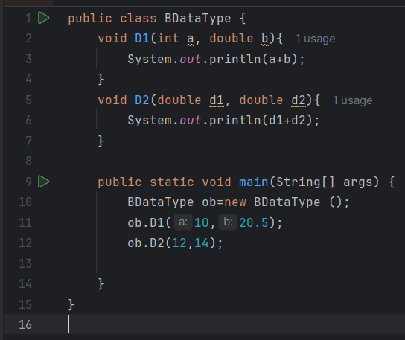
Discussion
This will show the ability of Java to distinguish between methods of the same name with different parameters. It calls each of the overloaded methods appropriately according to their argument types, which in turn shows the capability of Java's method resolution. The method D1 takes an int and a double, while D2 takes two double arguments. In this way, it will clearly be able to show overloading, where each method does something different according to its parameters.
The Output will show like:
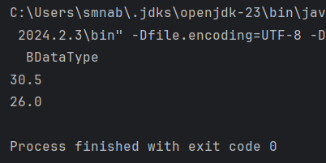
Conclusion
This laboratory provided insight into method overloading in Java. This experiment has shown that Java could identify the differentiation between methods of the same name by looking at their parameter types, so it can reuse method names with different parameter lists. It also paves a way for code readability and maintainability because it is going to provide flexibility in coding while calling a method.

Code 2: Understanding Variable-Length Argument Lists in Java
Objective
In this lab is to practice with variable-length argument lists, also known as varargs, in Java by implementing a class named BUnlimitedData. This exercise will help show how one method can be created to handle a variable amount of integer arguments using Java. This makes the handling of parameters easier and more dynamic in Java applications.
Components Used
- Java Development Kit
- IDE such as IntelliJ IDEA or Eclipse
- Computer system with the essential software installed
Theory
Java has something known as Variable-Length Argument Lists. These are method parameters that can take zero to many arguments of a given type. It gives the programmer more flexibility as it has to deal with only variable number of inputs. It is defined as type. parameter where one can pass any number of arguments from zero upwards and they will be handled inside of a receiver's array.
In this example, class BUnlimitedData defines a method named D that uses varargs to accept an arbitrary number of int inputs and prints their sum. Varargs is extremely helpful when we cannot anticipate with certainty just how many arguments might be passed into a particular method.
Problem Solving Procedure
1. Class Definition: Define a class called BUnlimitedData.
2. Create the Varargs Method:
- Define the method D using the syntax int. a so it can receive any number of integer parameters.
- Use the for loop to iterate the integers in array a and sum them up.
- Print out the sum.

3. Write the Main Method: In this main method, create an instance of BUnlimitedData and called the D method with different numbers of arguments.
4. Execute and See the Output: Compile and execute the program to ensure that D correctly calculates and prints the sum for any number of arguments.

Code
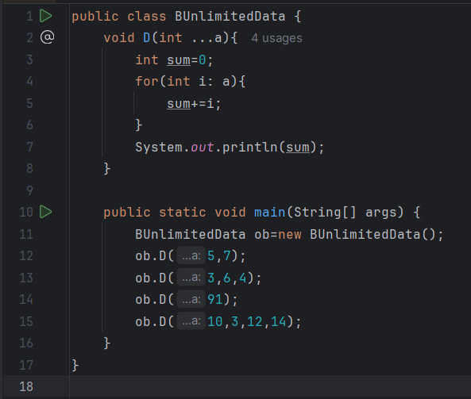
Discussion
Following is the code that can be used to demonstrate the power of Java's varargs, enabling a single method, D, to accept multiple calls with different quantities of parameters without declaring methods or arrays for each case. All supplied int parameters are combined into an array so a for loop to add them up can be rapidly developed. It's so effortless to input various numbers this way and avoids redundancy. The example is a bit contrived, but such code is not all that uncommon.

The Output will show like:
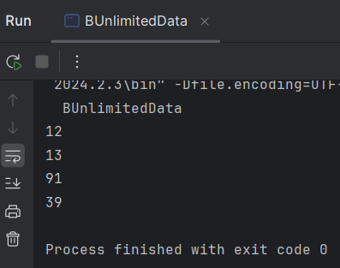
Conclusion
This lab demonstrates how to work in Java with varargs, a way of simplifying the treatment of methods with variable numbers of arguments. With one method and an open-ended parameter list, the solution is compact and reusable. Additionally, this makes Java methods much more adaptable because now they can handle any number of arguments.

